**EXPERIMENT NO 9**

**VIEWS**

**Aim:**

* Create table student with attributes id, name and department.
* Display
* Create view and select
* Insert values
* Create view with check option
* Insert values and alter table.

**Components:**

Views: Views in SQL are kind of virtual tables. A view also has rows and columns as they are in a real table in the database. We can create a view by selecting fields from one or more tables present in the database. A View can either have all the rows of a table or specific rows based on certain condition.

**CODE**

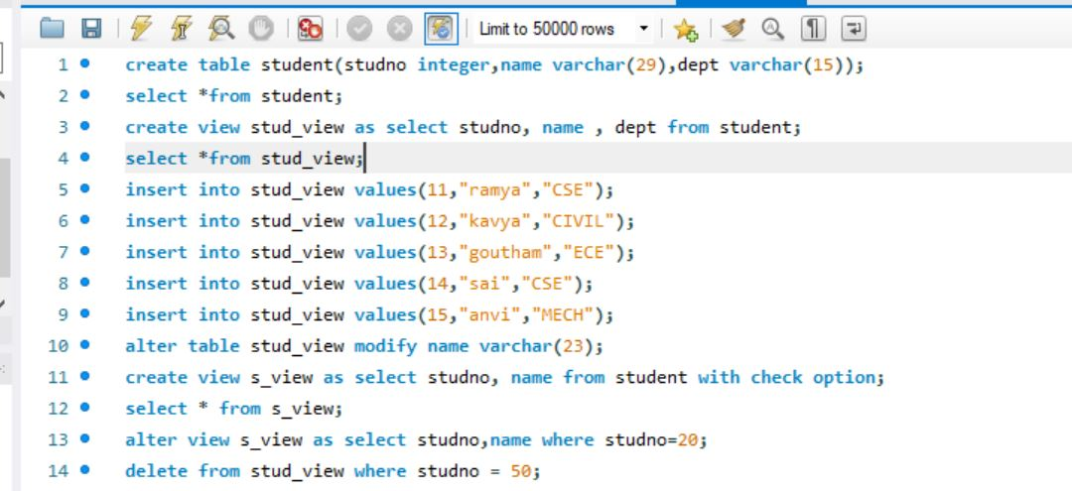



**OUTPUT**



